Title and subtitle with crop mark graphicCrop mark graphic



**CONCEPT USED: STRUCTURES**

**OBJECTIVE:**

To make a library management system for handling of data and managing day to day operations.

**PROBLEM DEFINITION:**

We use structures to define a set and store data to solve the problem of manual hardwork which is time consuming and instead use this method which is more efficient and less prone to errors.

**PURPOSE OF LIBRARY MANAGEMENT SOFTWARE**

* The purpose of a library management system is to manage the functioning of a library with efficiency and reduced costs. Automation of tasks reduces the amount of manual work required.
* We can use programs for issuing books, keeping track of issues, cataloging, indexing, checking availability and implementation of fines.This also minimizes the chances of errors*.*
* The system is handy and easy to use for both officials and students.We can also enhance this system with more features such as an entry record, and to store

e- books. Overall,the system can be modified as per needs of the institution.

**ALGORITHM**

STEP 1: Declare the structure which holds the data member.

STEP 2: Declare the variables which are used for loops.

STEP 3: Use switch cases to work on each module.

STEP 4:Case 1: Adding Book Information.

Case 2: For Displaying Book Information.

Case 3: For Displaying Book by Using Author Name.

Case 4: For Displaying Book by Using Book Name.

Case 5: To Display the Number of Books in Library.

Case 6: To Exit.

**FLOWCHART**

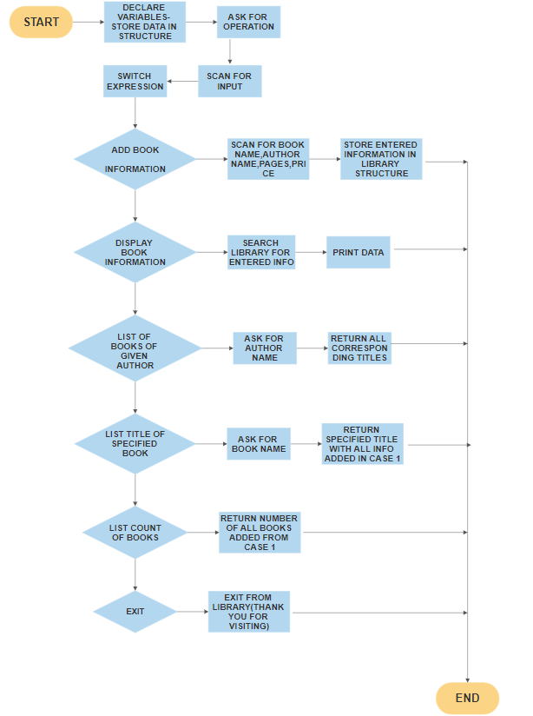

**CODE IN C LANGUAGE**

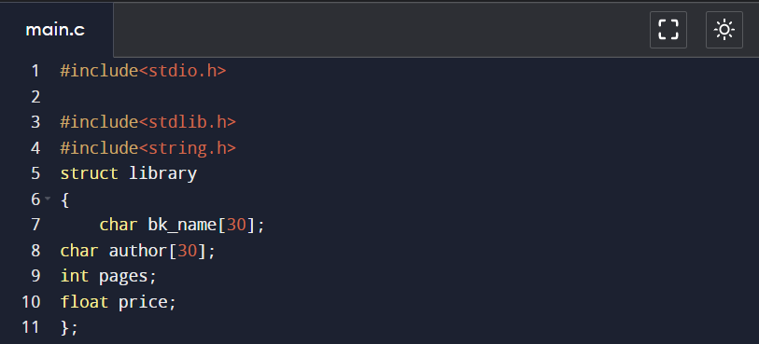

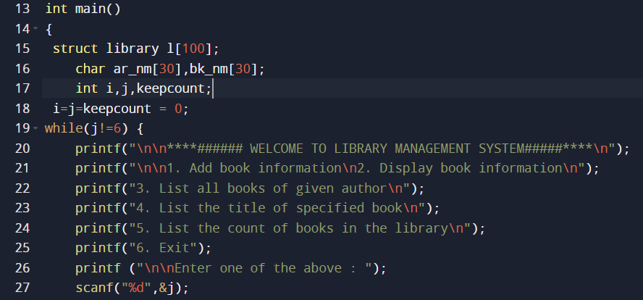

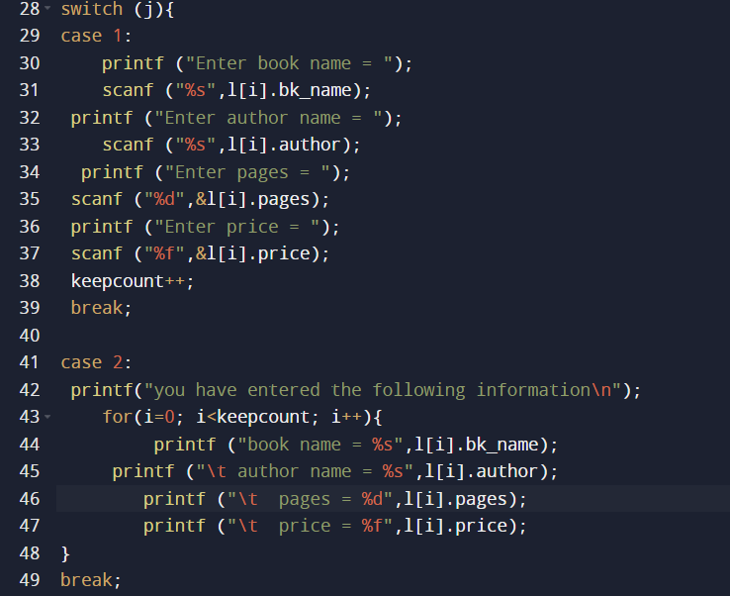

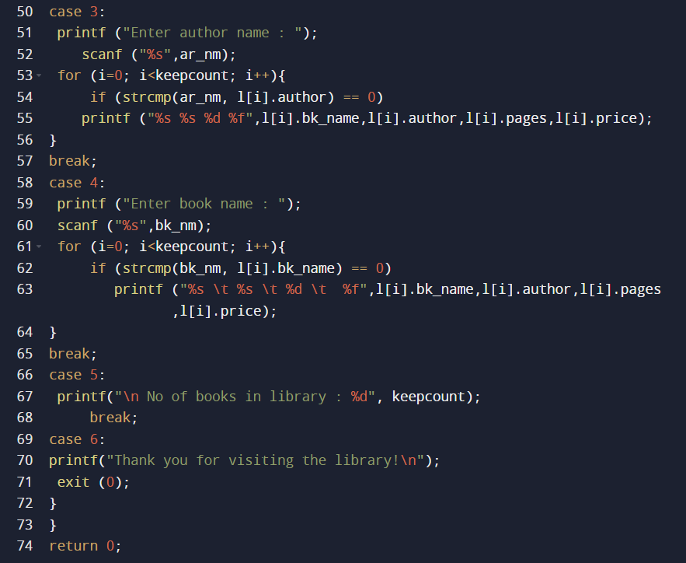

#include<stdio.h>

#include<stdlib.h>

#include<string.h>

struct library

{

char bk_name[30];

char author[30];

int pages;

float price;

};

int main()

{

struct library l[100];

char ar_nm[30],bk_nm[30];

int i,j,keepcount;

i=j=keepcount = 0;

while(j!=6) {

printf("\n\n****###### WELCOME TO LIBRARY MANAGEMENT SYSTEM#####****\n");

printf("\n\n1. Add book information\n2. Display book information\n");

printf("3. List all books of given author\n");

printf("4. List the title of specified book\n");

printf("5. List the count of books in the library\n");

printf("6. Exit");

printf ("\n\nEnter one of the above : ");

scanf("%d",&j);

switch (j){

case 1:

printf ("Enter book name = ");

scanf ("%s",l[i].bk_name);

printf ("Enter author name = ");

scanf ("%s",l[i].author);

printf ("Enter pages = ");

scanf ("%d",&l[i].pages);

printf ("Enter price = ");

scanf ("%f",&l[i].price);

keepcount++;

break;

case 2:

printf("you have entered the following information\n");

for(i=0; i<keepcount; i++){

printf ("book name = %s",l[i].bk_name);

printf ("\t author name = %s",l[i].author);

printf ("\t pages = %d",l[i].pages);

printf ("\t price = %f",l[i].price);

}

break;

case 3:

printf ("Enter author name : ");

scanf ("%s",ar_nm);

for (i=0; i<keepcount; i++){

if (strcmp(ar_nm, l[i].author) == 0)

printf ("%s %s %d %f\n",l[i].bk_name,l[i].author,l[i].pages,l[i].price);

}

break;

case 4:

printf ("Enter book name : ");

scanf ("%s",bk_nm);

for (i=0; i<keepcount; i++){

if (strcmp(bk_nm, l[i].bk_name) == 0)

printf ("%s \t %s \t %d \t %f",l[i].bk_name,l[i].author,l[i].pages,l[i].price);

}

break;

case 5:

printf("\n No of books in library : %d", keepcount);

break;

case 6:

printf("Thank you for visiting the library!\n");

exit (0);

}

}

return 0;

}

**OUTPUTS FOR THE CODE**

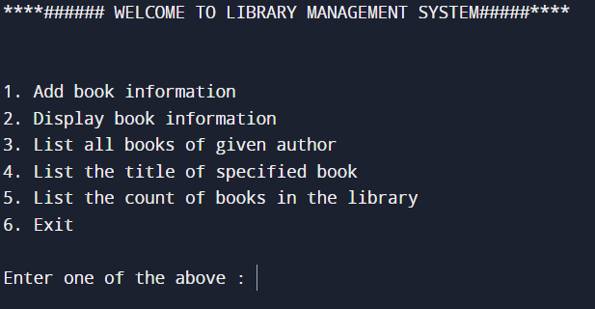

**OUTPUT( AND DATA SUBMISSION) FOR CASE 1**

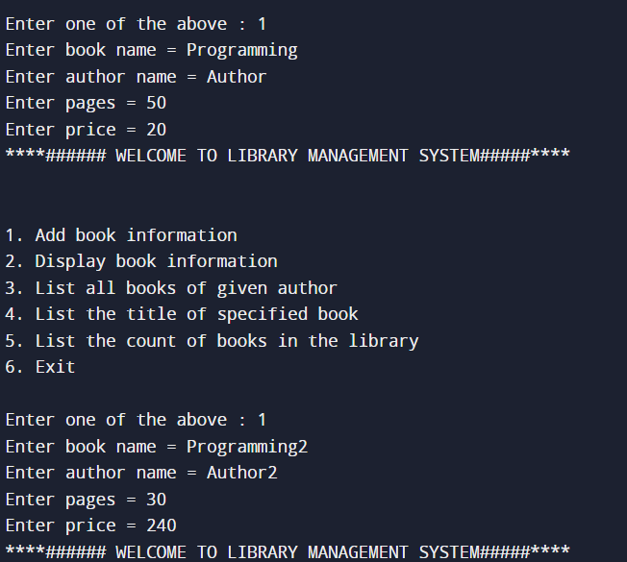

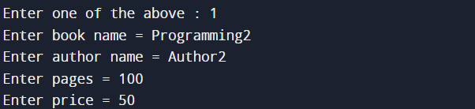

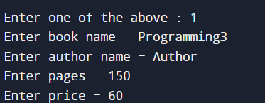

**OUTPUT FOR CASE 2**

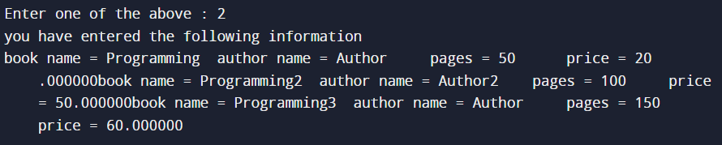

**OUTPUT FOR CASE 3**

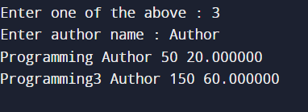

**OUTPUT FOR CASE 4**

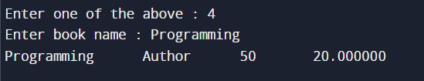

**OUTPUT FOR CASE 5**

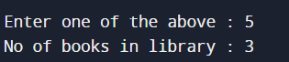

**OUTPUT FOR CASE 6**

